TB epidemic status
Georgia has achieved a remarkable progress in its fight against Tuberculosis. During the last several years TB case notification has been decreasing on average by 9% annually. Robust and sustainable surveillance system assures us that this trend reflects a genuine reduction in TB incidence. According to the National TB Program notifications data, a total of 2 913 TB cases (all forms) were registered in 2017 (including, in penitentiary sector), which is 78 cases per 100,000 population; out of these, 2,131 were new cases (57 per 100,000).

Tuberculosis
Hewlett-Packard Company | [Pick the date] | [Edition 1, Volume 1]

DR-TB prevalence in Georgia (2005-2017)
TB incidence in European Region (2016)
20055
From 2016 Georgia is not listed among the high MDR TB burden countries. However, according to the WHO Euro surveillance report (2018), the estimated incidence rate of all forms in 2016 was 92 per 100,000 population, which places Georgia among the top three countries by estimated incidence in the WHO European Region.

National efforts towards reaching End TB Strategy goals

Main Challenges
Significant share of multi-drug resistant (MDR) TB and high loss-to-follow up rate are the key challenges for the National TB Program and for effective TB control in the country. As a response to these challenges, the country elaborated and started implementation of a national strategy to stop the spread of TB and to reduce the burden of MDR-TB and especially of extensively drug resistant (XDR) TB. The strategy covers a comprehensive spectrum of interventions including updating TB management guidelines and offering individual treatment adherence support package.

The country met MDG 6c and the Stop TB Partnership 2015 targets to reduce prevalence and mortality rates of TB by 50% compared to 1990 and demonstrated commitment to achieve the milestone of further reducing TB incidence as part of the End TB strategy.
Correspondingly Georgia implements interventions aimed to meet all three requirements of End-TB.

TB treatment outcomes in European Region (2014) (2016)

Requirement 1: Expanding the scope and reach of interventions with a focus on high-impact, integrated and patient-centered approaches.
49
69
84

- Georgia

- Europe
- With Global Fund support Georgia has established universal access to TB care leading to improved case detection and treatment success rates.
- The country introduced modern diagnostic methods approved by the WHO: culture on solid and liquid media, GeneXpert MTB/RIF systems for rapid diagnosis of TB and MDR-TB.
- FAST strategy was successfully piloted and rolled out to promote early detection and prevent disease transmission in general healthcare facilities.
- Georgia was one of the first countries to ensure programmatic use of the new TB drugs.
- Diverse approaches are used to strengthen PHC provider engagement in TB control countrywide.

GeneXpert machine
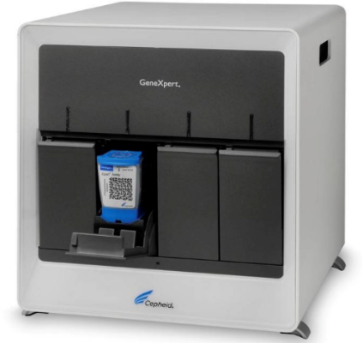

Requirement 2: Eliciting full benefits of health and development policies and systems through engaging a much wider set of collaborators across government, communities and the private sector.

- National TB program in Georgia is a model for public-private collaboration, which enables universal access to TB care and leads to improved case detection and treatment success rates.
- National Strategic Plan for Tuberculosis Control in Georgia 2016-2020 and Transition Plan from donor funding to domestic funding were developed through multilateral dialogue, including with civil society engagement and are now endorsed by the government.
- Nation Centre of Disease Control and Public Health as a Principal Recipient of Global Fund grants and implementer of the state TB program has established an integrated supply chain management system to make use of global supply mechanisms through Global Drug Facility and to ensure efficient delivery of quality drugs and consumables.
- Within the frames of TB EECA project on strengthening health systems for TB control (TB-Rep), Georgia has established strong collaboration with international partners and local stakeholders to ensure TB program effectiveness and sustainability.

Requirement 3: Pursuing new scientific knowledge and innovations that can dramatically change TB prevention and care.

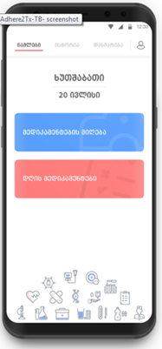
- Georgia has been part of multi-central research projects such as: FIND, EXPAND TB, STREAM, STAND, END-TB, Nix-TB.
- Innovative technologies and service delivery models have been developed and implemented within National TB Program, namely:
  - Civil-society engagement improved program coverage and outcomes for hard-to-reach groups: with GF support NGO “Centre of Bioethics Studies and Culture” in collaboration with Georgia Orthodox Church organizes screening for TB in Christian monasteries, nunneries and eparchies, as well as for Muslim communities.
  - Community-based organization New Vector, in partnership with Patient Union provides treatment adherence support to MDR TB patients in five cities with highest prevalence of MDR TB: Tbilisi, Kutaisi, Batumi, Zugdidi and Rustavi. The adherence support is delivered by a team composed of a social worker, psychologist and former TB patient.
  - Mobile-based application was developed for Video Observed Therapy (VOT). Patients are enabled to take drugs at a convenient time and send the record to VOT nurse. 89 patients were enrolled in VOT during one year implementation and no dose was omitted.
Video Observed Treatment

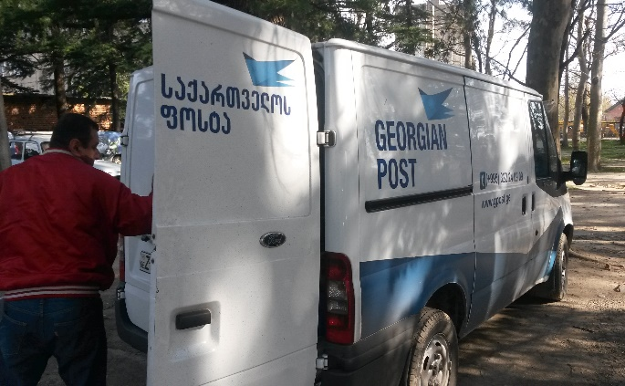
  - Mobile DOT unit provides another option to ensure access to services for patients living in remote from care site areas.
  - Tablet-based software was developed for epidemiologists to ensure high quality patient education and counselling.
  - Novel approach to speed up sputum transportation was introduced in 2013 allowing care providers to send sputum samples through the national postal service. This new scheme improved timeliness, levelled lab workload and decreased transportation cost almost 8 times.

Sputum Sample Transportation through Georgian Post

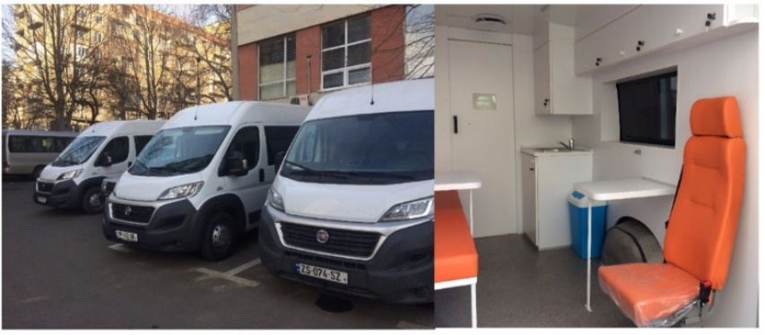
Mobile outpatient units

- The country is piloting integrated HCV-HIV-TB screening, diagnosis and treatment approach to enable comprehensive care delivery at primary care level and to promote health outcomes in Samegrelo region. The effort is based on a public-private partnership. Technical assistance, including development of screening protocol and trainings, is funded by the Global Fund, while test kits are procured from the state budget and incentives for providers are payed by the local government.
- Zero TB project has been launched in Adjara region with the aim to create ‘island of elimination’ that will contribute to lowering rates of TB in Adjara region and in Georgia overall. The project captures two directions: improved case detection and treatment outcomes through comprehensive TB case management.
- Results Based Financing model is under development.

________________________________________________________________________________________
  Ministry of Labour, Health and Social Affairs of Georgia  144, A. Tsereteli avenue. Tbilisi, Georgia, 0119  www.moh.gov.ge | 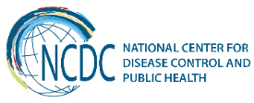  National Center for Disease Control and Public Health  9, M. Asatiani street. Tbilisi, Georgia, 0177  www.ncdc.ge

